**Jenkins Assignment - 1**

● Trigger a pipeline using Git when push on Develop branch

● Pipeline should pull git content to a folder.

* Creating a Pipeline

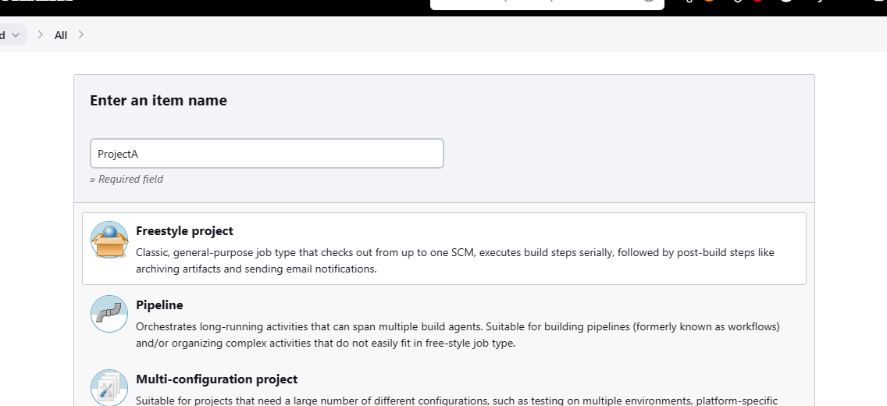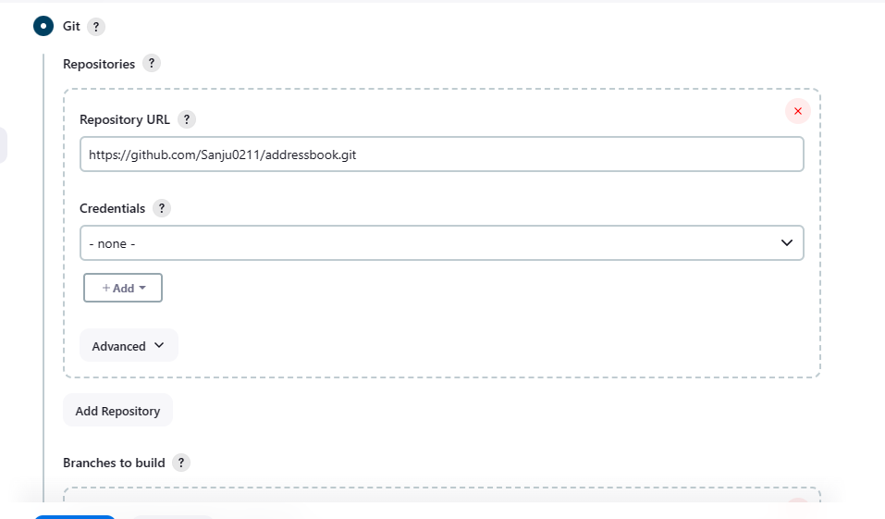

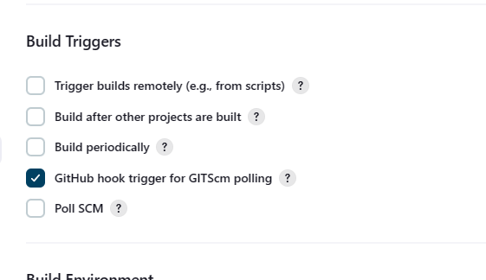

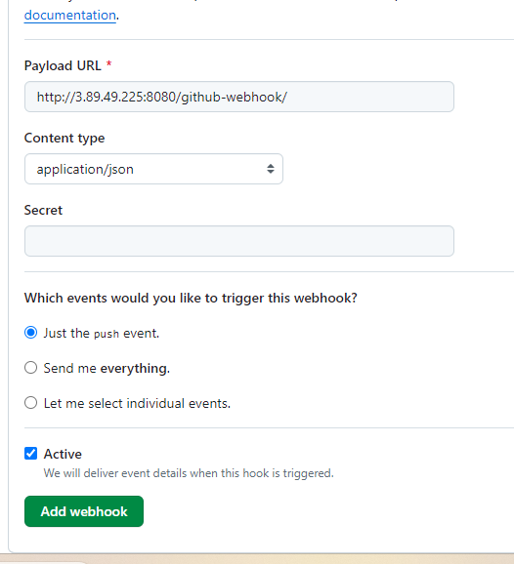

* Cloneing Git repository
* Creating Develop Branch and adding few files in it.

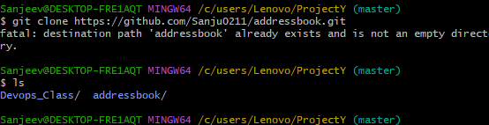

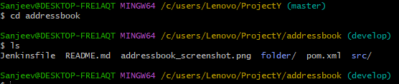

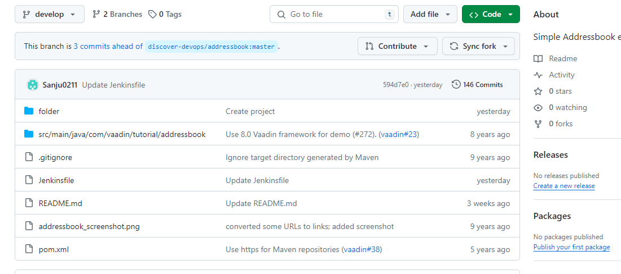

* Triggering a pipeline with Git Pull : content on Develop branch got added on Workspace

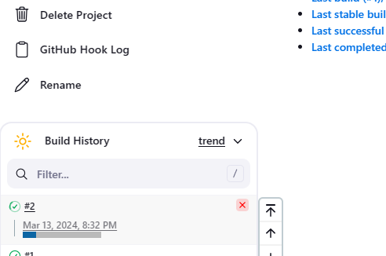

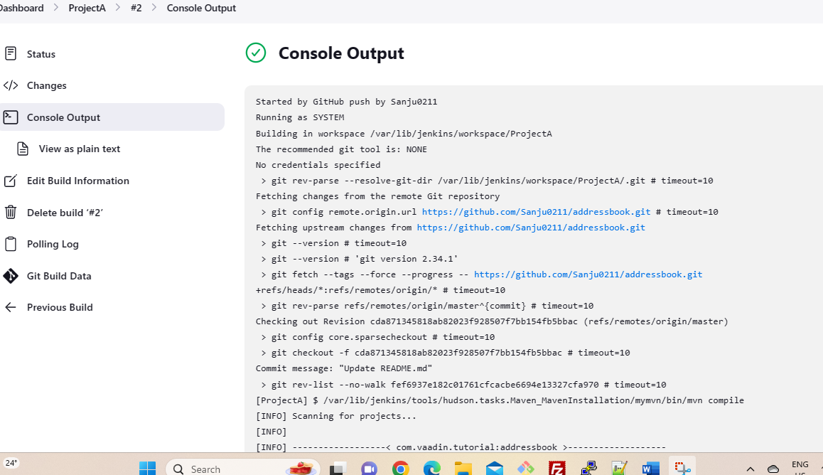

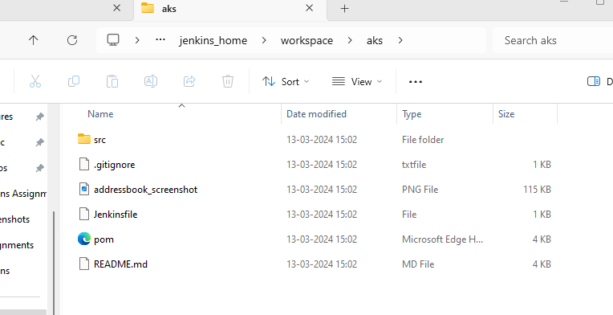

**Jenkins Assignment - 2**

● **Add 2 nodes to Jenkins master**

**● Create 2 jobs with the following jobs: 1. Push to test. 2. Push to prod**

**● Once a push is made to test branch copy git files to test server**

**● Once a push is made to master branch copy git files to prod server**

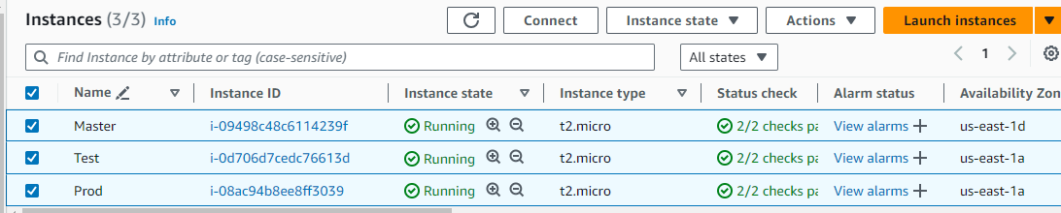

* Installing java and Jenkins on Master node

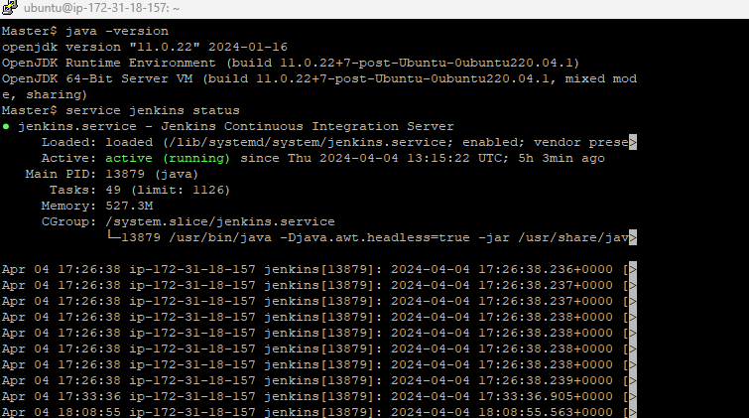

* Installing java on slave nodes – Test & Prod

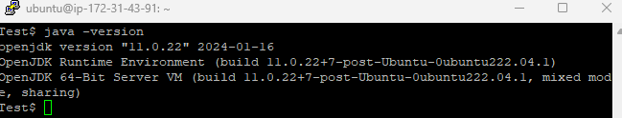

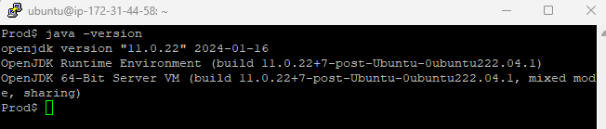

* Making ssh connection to slave nodes.

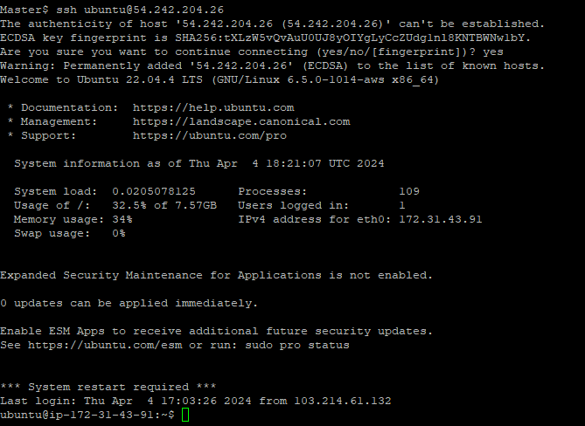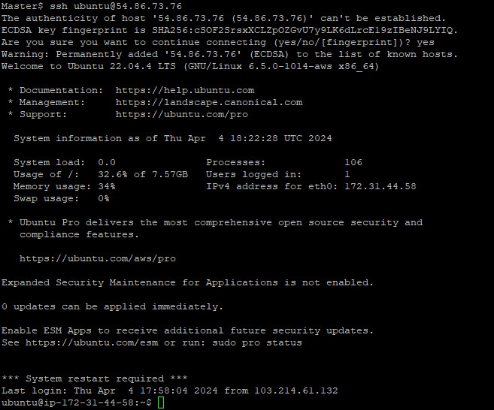

* Creating 2 Agents on Jenkins Master

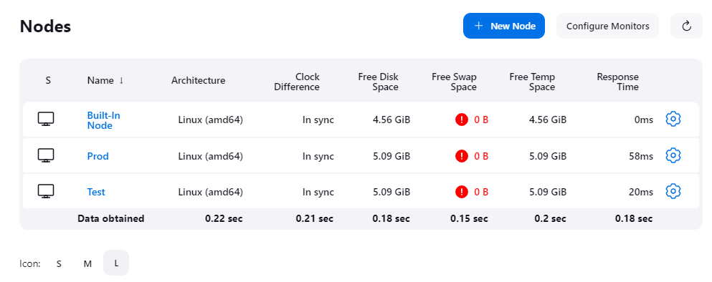

* Creating 2 Jobs –> Test & Prod

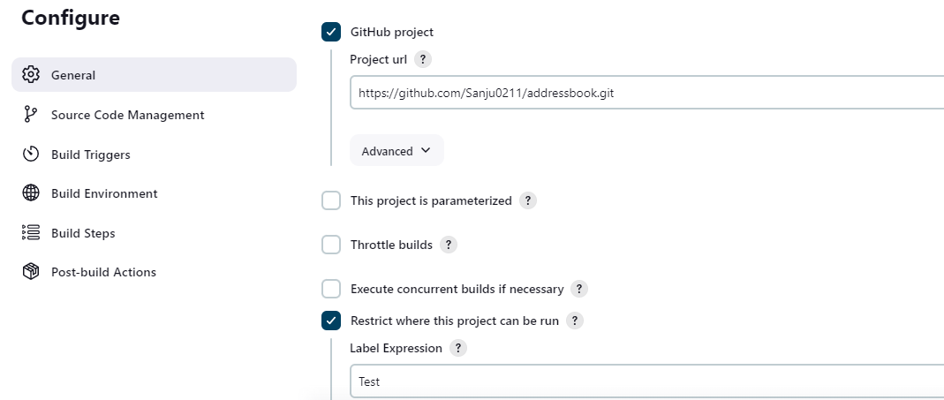

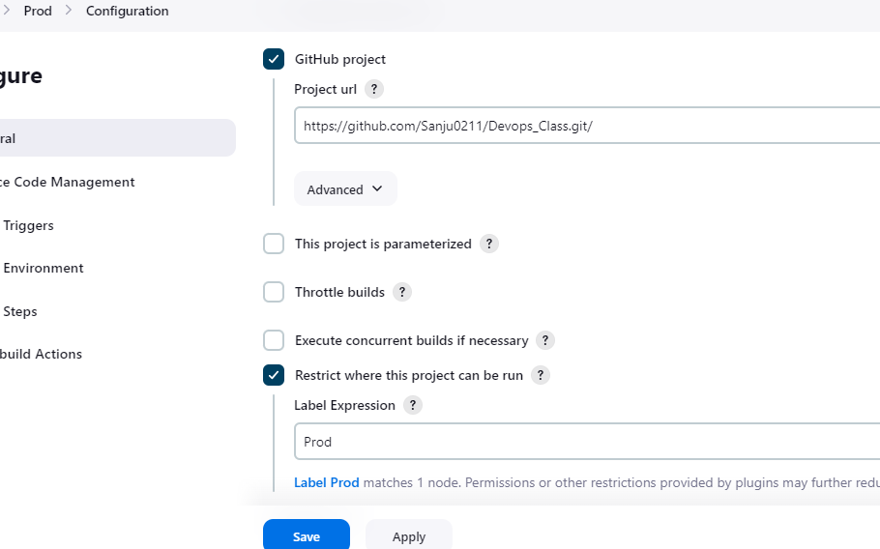

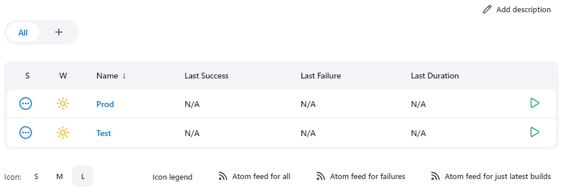

* Creating test branch and a text file inside it.

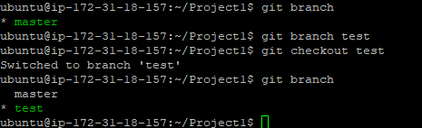

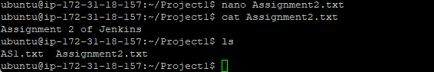

* Pushing to Github from Test :

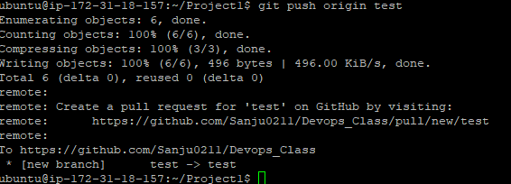

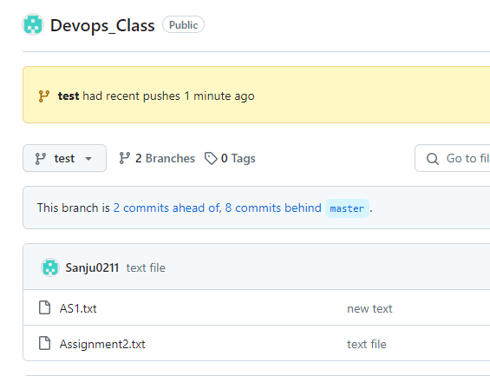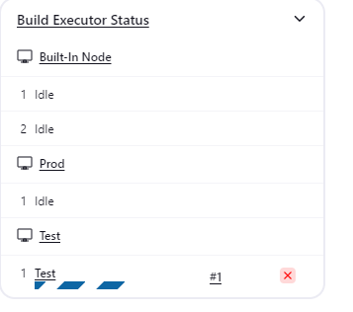

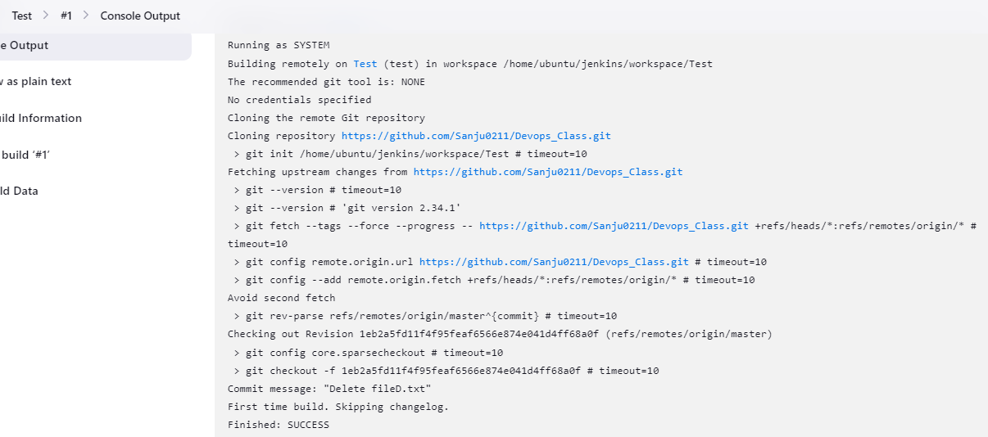

Files were pulled to Slave node –> Test :

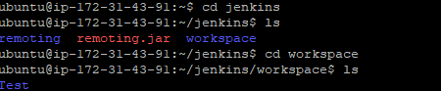



Pushing to Github from Master:

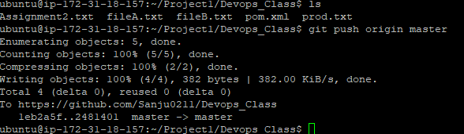

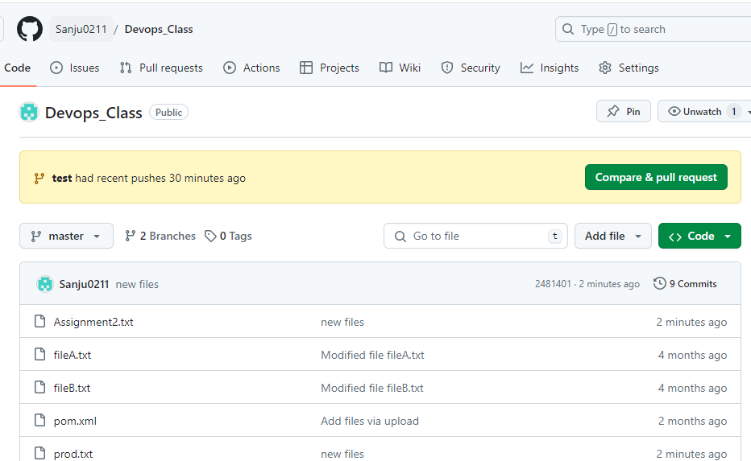

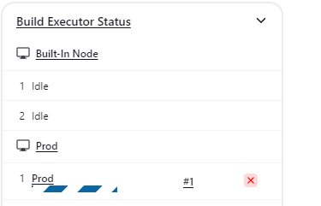

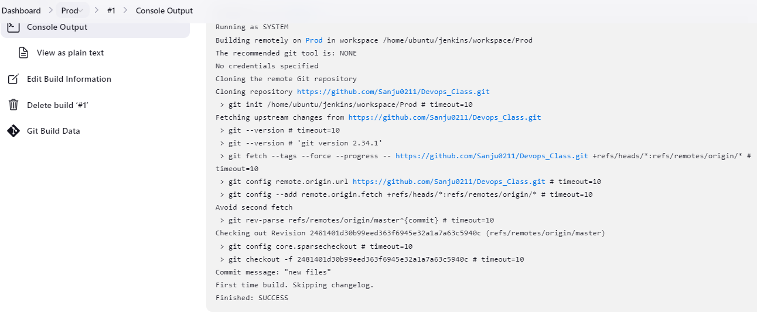

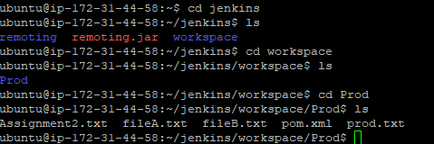

**Jenkins Assignment – 3**

**● Create a pipeline in Jenkins**

**● Once push is made to “develop” branch in git, trigger job “test”. This will copy git files to test node**

**● If test job is successful, then prod job should be triggered**

**● Prod jobs should copy files to prod node.**



* Installing java and Jenkins on Master node



* Installing java on slave nodes – Test & Prod





* Making ssh connection to slave nodes.



* Creating 2 Agents on Jenkins Master



Creating 2 Jobs –> Test & Prod





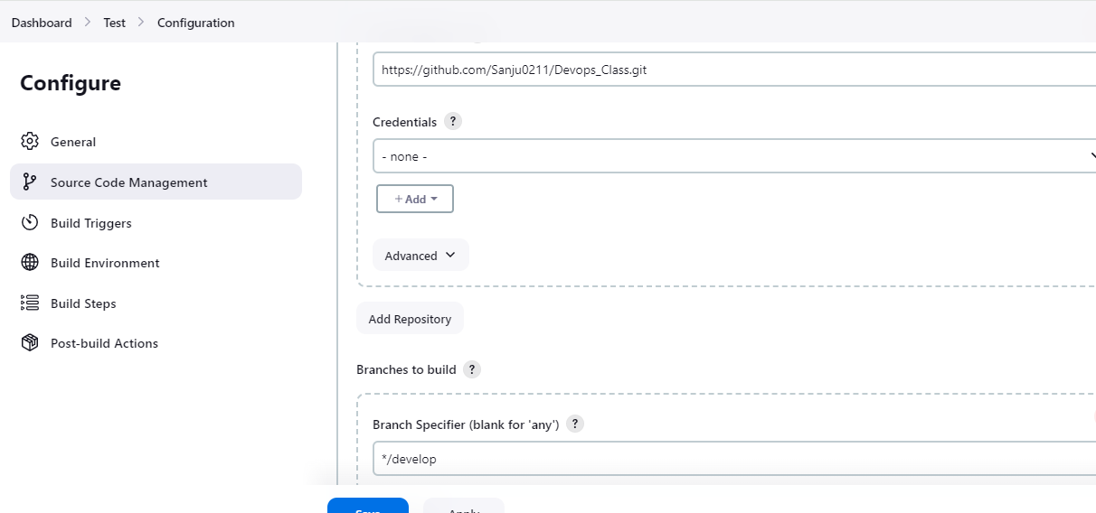

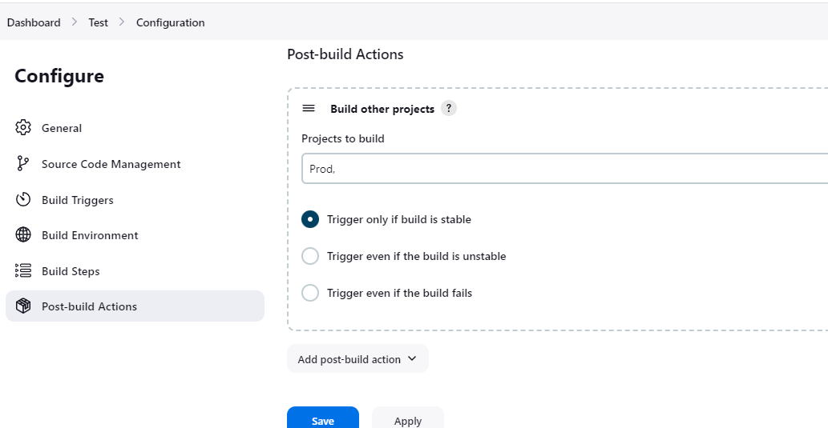



* Git Push to develop branch

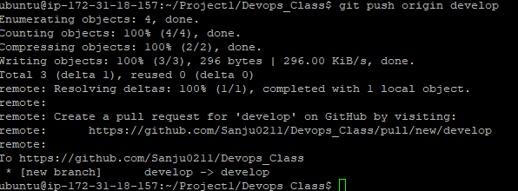

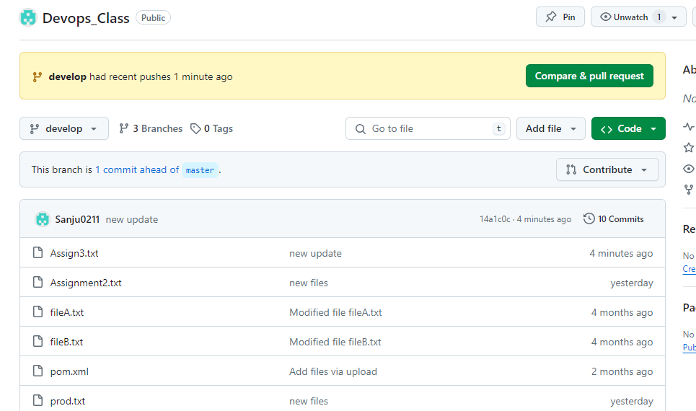

**Trigger Initiated**: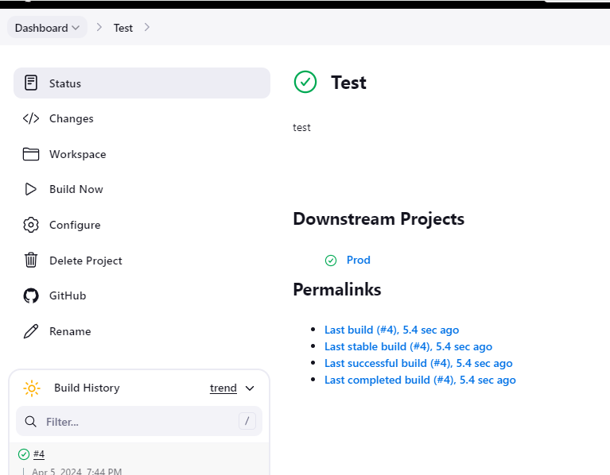

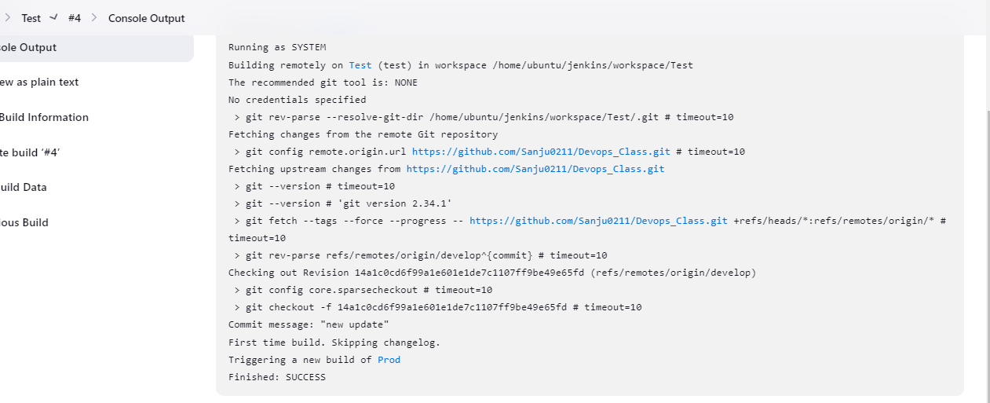

**After test-job has run successfully immediately Prod-job ran successfully**

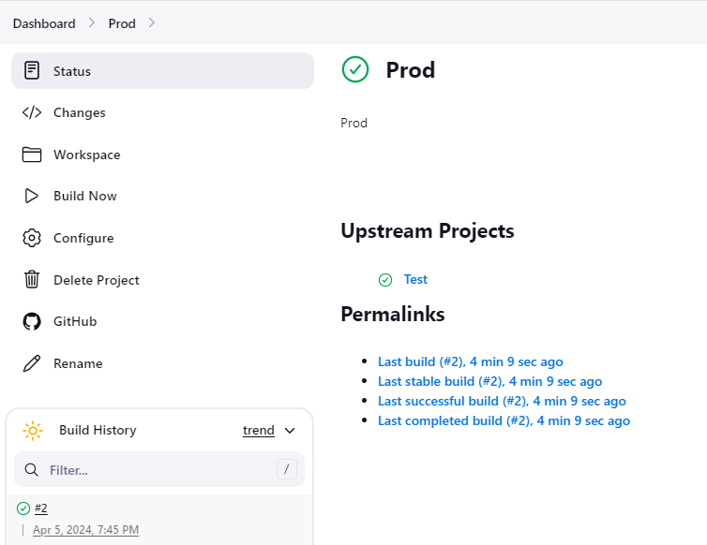

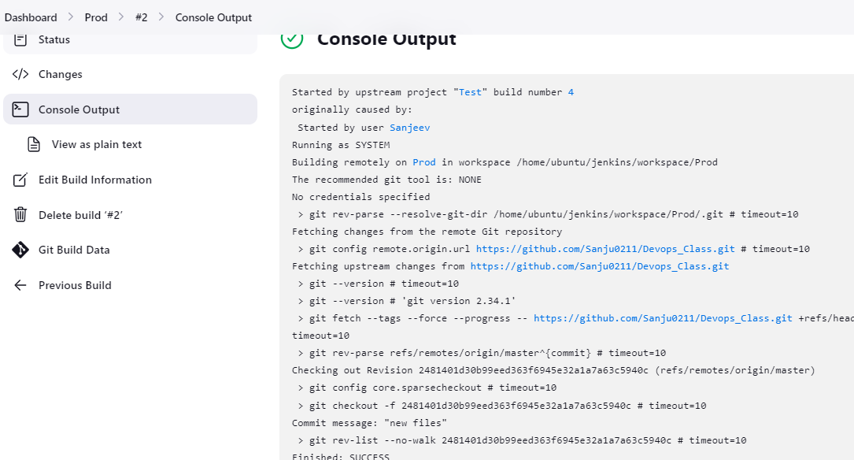

**File were pulled on both Test and Prod servers:**

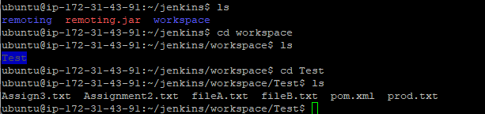

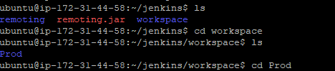



**Integration of Devops tools with Jenkins**

You have been Hiredasa Devops Engineer in xyz software company. They want to implement CI/CD pipeline in their company. You have been asked to implement this lifecycle as fast as possible. As this is a product-based company, their product is available on this GitHub link. https://github.com/hshar/website.git

Following are the specifications of the Continuous integration:

1. Git Workflow has to be implemented

2. Code Build should automatically be triggered once commit is made to master branch or develop branch. If commit is made to master branch, build and publish website on port 82. If commit is made to develop branch, just build the product, do not publish.

3. Create a pipeline for the above tasks.

4. Create a container with Ubuntu and apache installed in it and use that container to build the code and the code should be on ‘/var/www/html’.

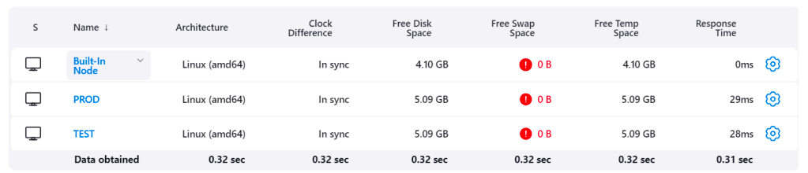

**Creating Nodes**

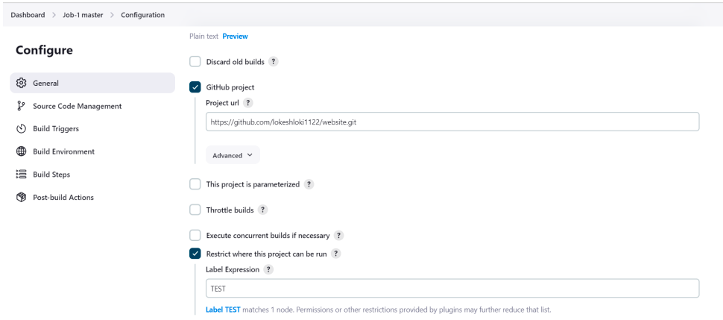

**Creating Job-1**

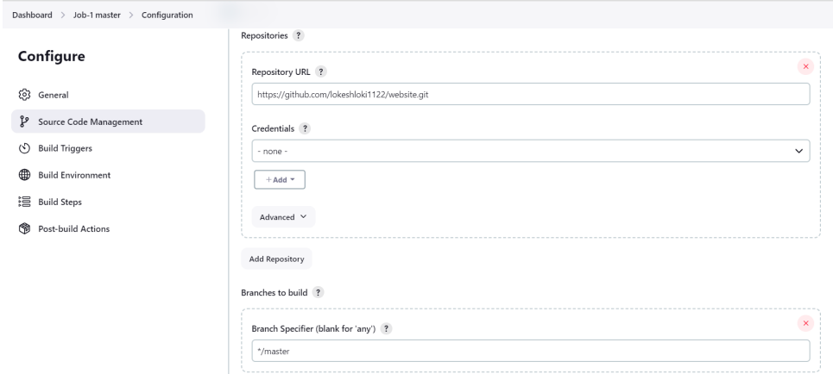

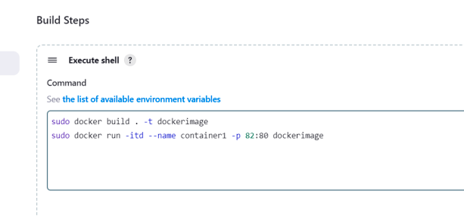

**Execution CMD’s**

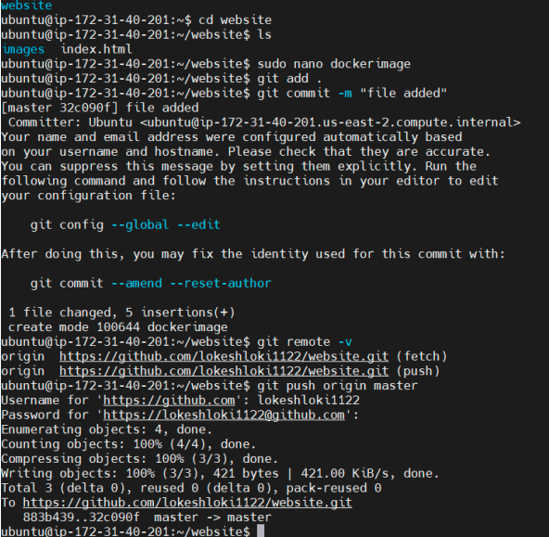

**Cloning the depository, Creating dockerfile, Committing it & Pushing in to github.**

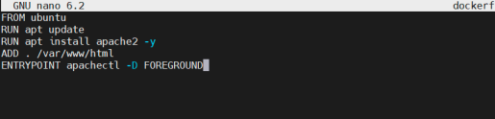

**Dockerfile**

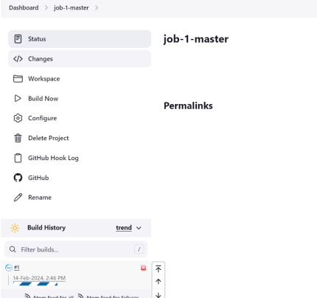

**Running Job-1**

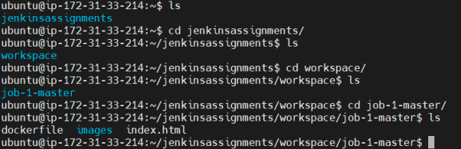

**Files were pulled**

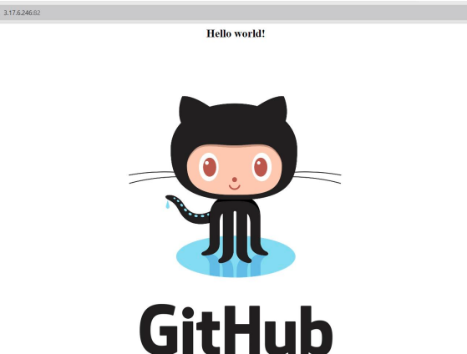

**Viewing the Webpage on port 82.**

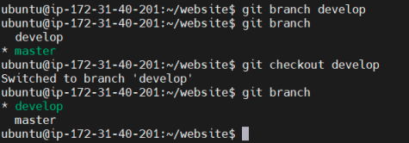

**Creating Develop branch.**

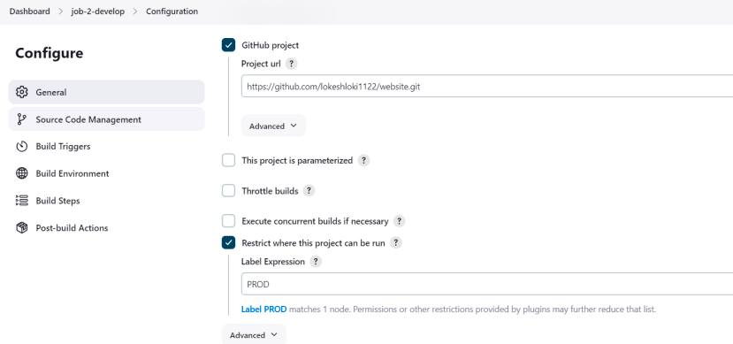

**Job-2 Creation**

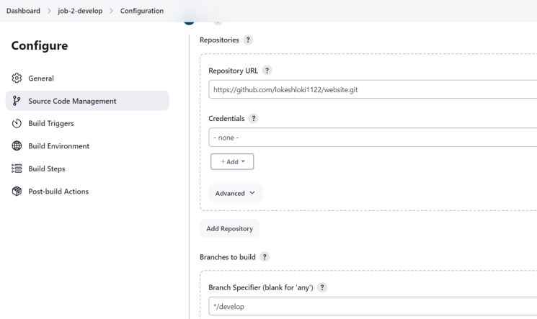

**Building on develop branch**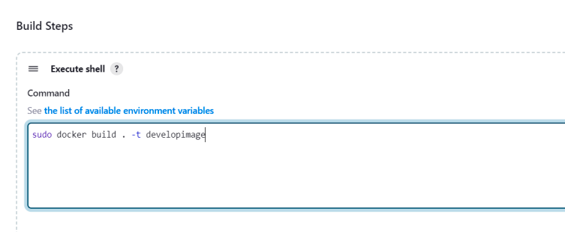

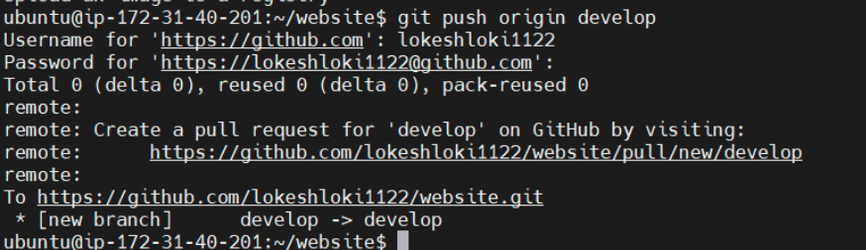

**Pushing to Github**

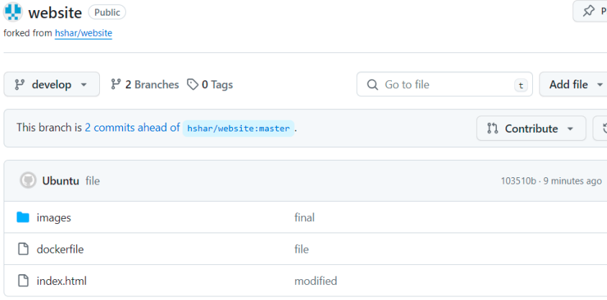

**Files pushed to Github**

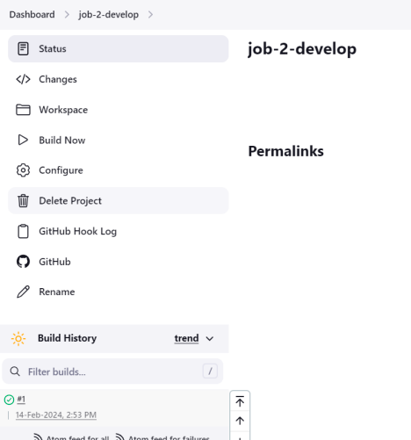

**Running Job-2**

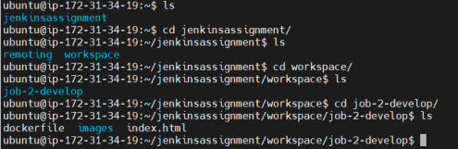

**Files were pulled to folder.**